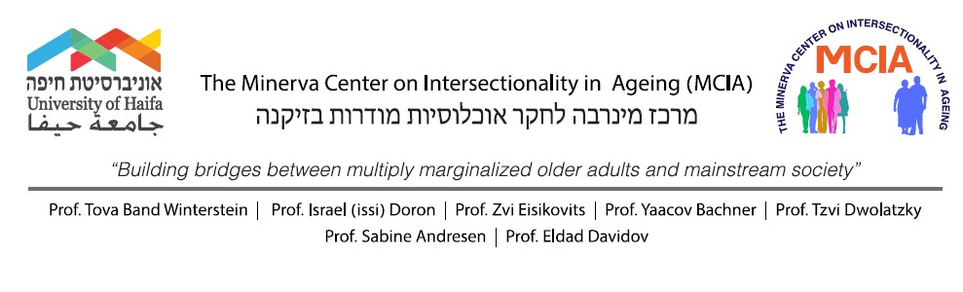
CALL FOR RESEARCH PROPOSALS:
THE INTERSECTIONALITY IN AGING DURING THE COVID-19
PANDEMIC
The Minerva Center for the Study on Intersectionality in Aging (MCIA) at the University of Haifa, Faculty of Welfare and Health Sciences is inviting researchers to submit research proposals.
The general purpose of the MCIA is to serve as an international venue and transnational forum for the study, research, training, education and dissemination of knowledge in the areas of institutional, cultural, socioeconomic, health and policy aspects of intersectionality in aging. We aim to apply and distribute systematic interdisciplinary research, using qualitative, quantitative, and mixed methodologies, using with the following populations:
- Immigrants and ethnic minorities in late life
- Older adults with diverse sexual orientations
- Aging and life-long disability
- Life-long engagement in violence, abuse and neglect. Older persons with lifelong engagement in crime
The coronavirus disease is a global pandemic affecting society at a large, with long-lasting psycho-social implications. Prone to heightened risk and compliant to the rigid instructions for social distancing, the elderly was considered as vulnerable to both the pandemic and the psychological effects of situations put in place to control it. This vulnerability is especially underlined for older adults of marginalized groups.
The MCIA invites researches to submit research proposals on the circumstances, risk and protection factors, intervention or prevention methods relevant to aging persons of marginalized groups during the COVID-19 pandemic era- up to 5000 Euro for a proposal.
The MCIA may fund the following expenses:
- Graduate student (doctoral and master level) scholarships
- Post-doctoral fellowships / visiting researchers (short and longer term)
- Workshops, colloquia and conferences
- Development of empirical databases
- Publications of relevant research products

Guidelines for the submission of proposals: The proposal should be no longer than five pages long (A4; Times New Roman; size 12; Double-space), and should include the following: (1) Rationale and aims; (2) Brief review of existing knowledge, (3)
Methodological remarks including sample and sampling, data collection, data analysis, and proposed time-line; and (4) expected outcomes and their potential scholarly and practice significance (5) list for expenses- Budget proposal
All applications must be accompanied by a curriculum vitae of the applicant(s).
Deadline: April 30st, 2021
To: Prof. Tova Band-Winterstein, PhD, Email: MCIA@univ.haifa.ac.il

